**INFORMATION GATHERED FROM SURVEY**

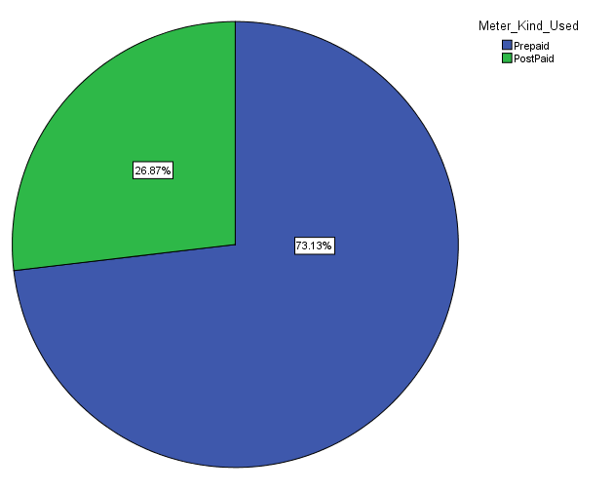

From the information gathered from customers who patronize the Electricity Company of Ghana(ECG), it can be deduced that 28% come to pay their bills and 73.13% come to buy units for their prepaid systems.

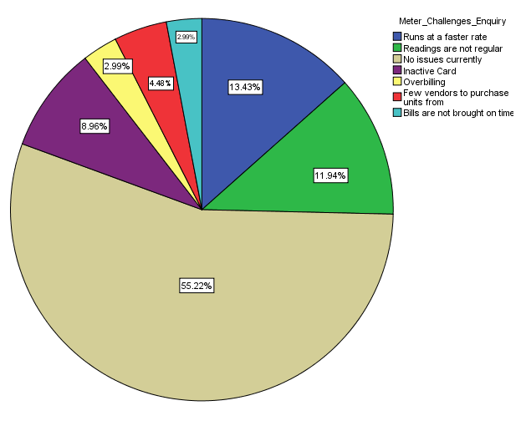

From the survey that was passed around, it was developed that 55.22% of the customers did not have any issues with relation to their specified meters. The rest of the customers that had issues were grouped under six main issue headings ranging from their prepaid units running faster due to no earth, irregular readings being recorded by the meter in a way that allowed their meter to be recording negative values instead of positive ones. Other prepaid customers also had issues with the fact that their cards were not working for their particular meter and some complain about the fact that they were served with blank meters. Some customers too had challenges with the fact that there only a few vendors in their vicinity hence the need to come all the way to Makola just to make a purchase. For the customers using postpaid their only issues were the fact that the bills brought did not come on time and they were also expensive. The Pie Chart above gives a detailed description of the percentage of the customers that encountered challenges with their meters.

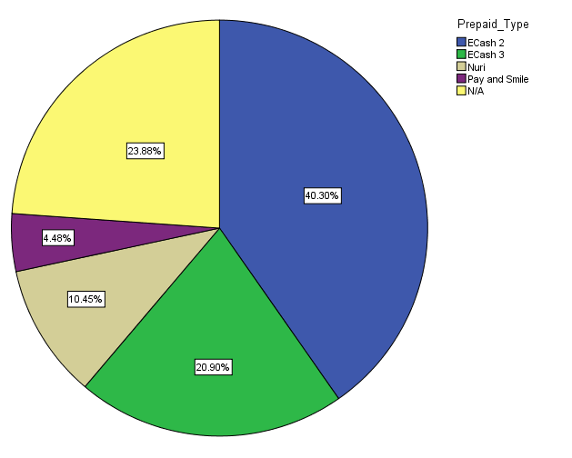

Customers were again asked about which prepaid meters they used. 23.88% out of the customers who answered this field were postpaid users hence the displayed options were not applicable to them. From the 76.12% customers that answered, it can be deduced that 40.30% of the prepaid users used the ECash 2 type of prepaid user. That is the type of prepaid which has the designated card being shown to the specified meter. ECash 3 had the second highest percentage of 20.90%. With this the customer has to insert the card into the meter to load or check credits. Nuri followed with a percentage of 10.45% and last but not the least the Pay and Smile(PNS) recorded a usage of 4.48%

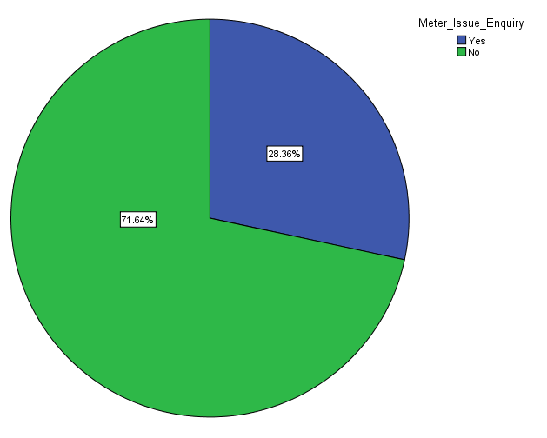

Additionally, customers were asked if they had any issues with their meters and 71.6% responded no. The rest which made a total percentage value of 28.36% had issues which they highlighted on in a follow up question in the survey.

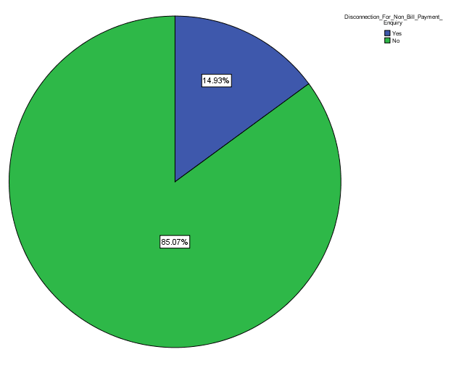

From the statistics displayed it can be inferred that, 14.93% of the customers that were interviewed had being disconnected from getting power to their respective homes or workplaces.

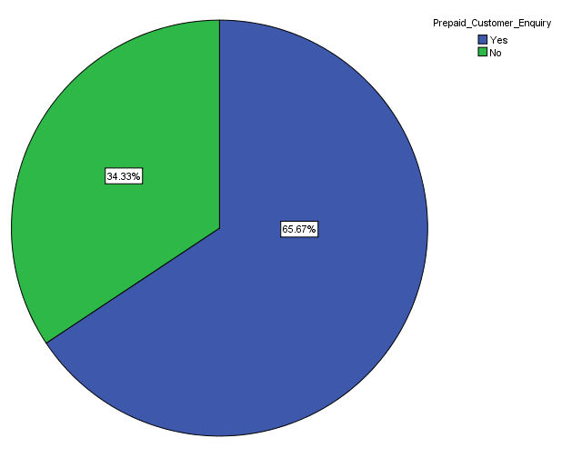

Asking a question of how many customers were prepaid users we recorded a percentage of 65.67% using the prepaid meters where units a bought or purchased before hand.

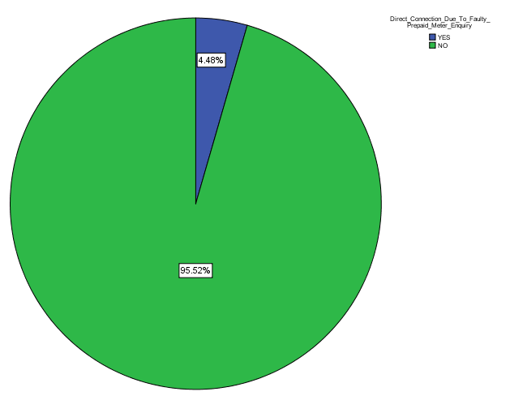

As a follow, up to the question customers who had being disconnected were asked if they were connected directly due to their prepaid meters being faulty. 4.48% of the customers who said yes asserted to the fact that they were connected directly

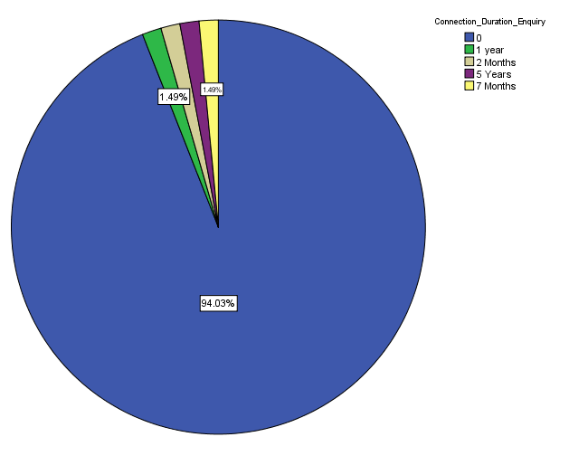

From the chart above one can make conclusions about the duration about the duration the customers were connected directly. Popular durations entered ranges from months to years..

